For people who are new to PUBG, it simply means Player Unknown's Battle Ground. This is one of the most exciting MOBA games and it is created by Proxima Beta. Currently, this game has a whooping over 500,000,000 gamers around the world. This impressive record is an indication that the game is popular among action gamers across the globe. The game is exclusively designed for mobile platforms and players can play the game anywhere, at any time.



PUBG Mobile is renowned because it offers an intense yet free single or multiplayer action gameplay. Every teenage gamer in the world has this intriguing game on their devices. Right now, the game has attracted a 4.6 rating on the Google Play Store by millions of gamers. You will love this game because of its awesome HD graphics and stimulating soundtracks. Download the PUGB Mobile game and enjoy beating all enemies to become the last man standing.

**The Exciting PUBG Mobile Gameplay**

Without a doubt, the PUBG mobile game boasts a huge number of worldwide players. At the same time, the team at Proxima Beta can also brag about having an epic creation that makes players glue their eyes on the tiny smartphone screens for hours. You will have to fight real players and build various fortifications to become a prominent PUBG player of all time. Everything is brought out so real from the weapons to skins, movement of characters to the game environment.



The plot of the game involves defeating enemies to survive. You need superior weapons and more tactical skills to overcome your opponent. Note that you should survive over 100 classic battles at every level. With unlimited money and diamonds, you will be able to unlock more weapons, skins, and other game elements. Download the PUBG Mobile and enjoy tremendous gameplay.

**PUBG Mobile Features**

PUGB game is not popular for nothing. It has spectacular features that make it stand out among other games in its genre. If you have not played this game before, you are missing out on the most thrilling gameplay. Here are highlights that will make you download and play the game today. https://modcombo.com

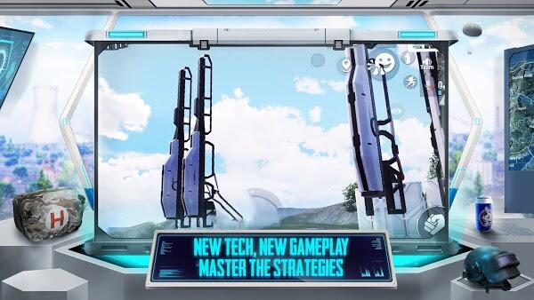

**The Safe Zones** – in this game, the safe zones consist of areas on the island where the gamer faces fewer or no enemies. In the initial levels of the game, the safe zones are large and quite easy to find. However, the safe zones become smaller in advanced levels and increase the risk of being attacked and killed by the enemy. As the gameplay becomes sizzling, you will need to leave the safe zones to survive attacks. Note that the safe zones will not remain the same at all levels. Rather, the safe zone will change to create more experiences that are challenging for players. Download the game now, find the safe zone and grab weapons to survive!

**Single and Multiplayer Mode** – the most amazing thing about the game is that it has both single and multiplayer modes. In the single-player mode, you will have no team to protect you. In case you are eliminated by a headshot, you will the game level with no one to revive you. On the other hand, the multi-player mode involves making a squad of players that you can play along with. You can make a squad with up to 4 people. This means that you can enjoy playing the game with your friends and relatives. The benefit of playing alongside other gamers is that you will be revived in case your opponent shoots you. https://modcombo.com

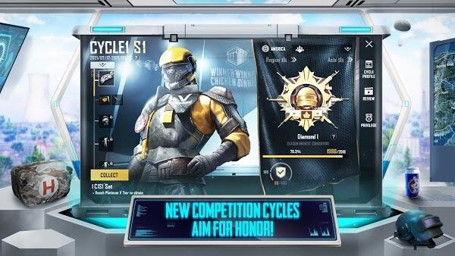

**See Through Wall** – this feature allows players to see and know the location of enemies through walls and other solid objects. With this feature, you can see through walls, cars, trees, etc, and knock off your enemies without struggle. After locating the enemies, you need to avoid taking a shot across the objects. As in reality, you can’t shoot through concrete walls. In addition, this missed shot will make you be noticed and instead be taken down.

**Unlocking of PUBG Skins** – in PUBG Mobile, more skins and have been upgraded. You can unlock various skins with unlimited cash and countless battle points. The unlimited skins you can unlock during the gameplay include Gold Plate-S12K, The Olive Branch-Pan, Gold Plate-S686, Gold Plate-S12K, Shark Bite-KAR98K, The Olive Branch-Pan, Glory-AKM, Shark Bite-M16A4, Turquoise Delight-KAR98K, etc.